HDOC DAYS 10
Q1. Convert time in seconds into Days, Hours, Minutes and Seconds
1. Flowchart
Start
↓
Input total_sec
↓
days = total_sec / 86400
↓
rem = total_sec % 86400
↓
hours = rem / 3600
↓
rem = rem % 3600
↓
minutes = rem / 60
↓
seconds = rem % 60
↓
Display days, hours, minutes, seconds
↓
End
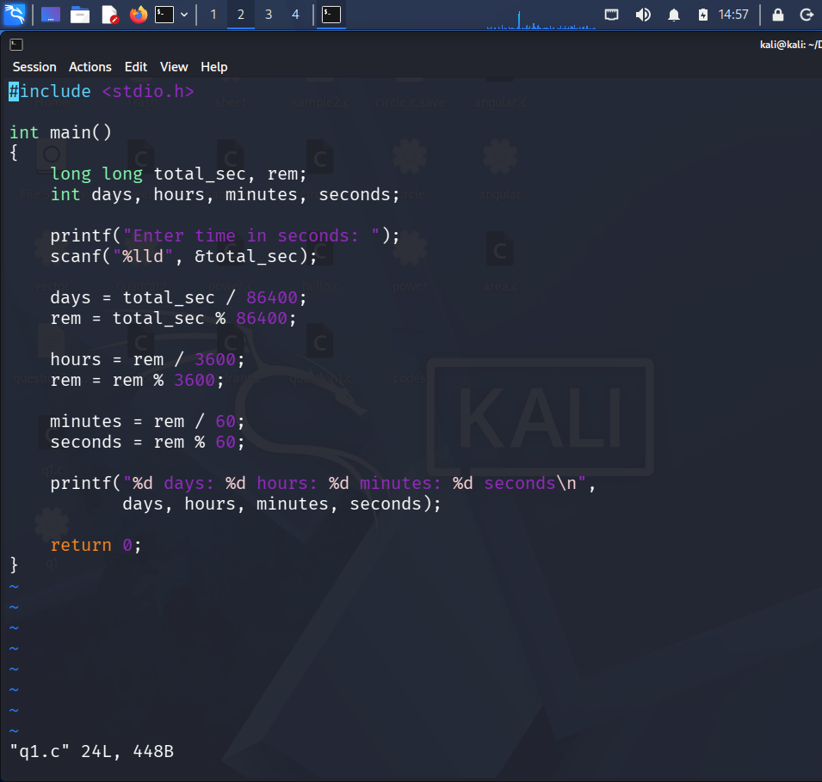
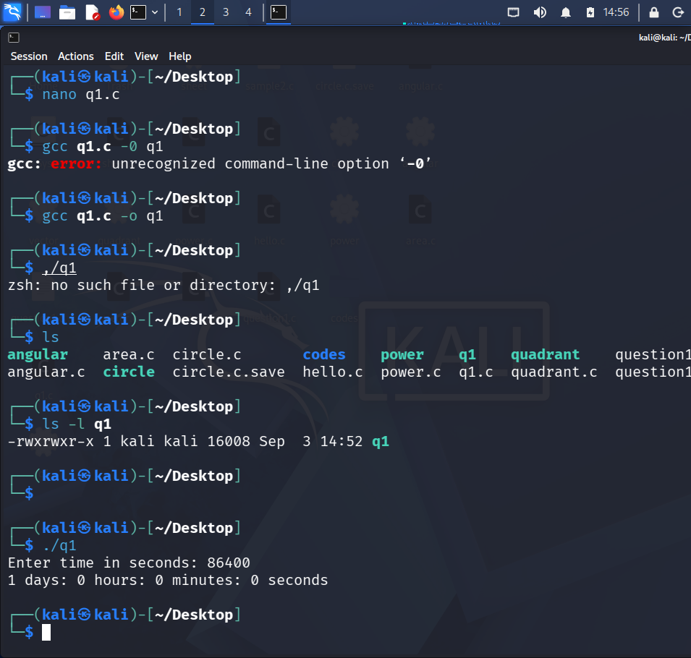
2. Pseudocode
- Start
- Declare total_sec, days, hours, minutes, seconds, rem
- Input total_sec
- Calculate days = total_sec / 86400
- Calculate rem = total_sec % 86400
- Calculate hours = rem / 3600
- Calculate rem = rem % 3600
- Calculate minutes = rem / 60
- Calculate seconds = rem % 60
- Display days, hours, minutes and seconds
- Stop
3. Algorithm
- Start.
- Input time in seconds.
- Divide total seconds by 86400 to get days.
- Find remaining seconds using % 86400.
- Divide remaining seconds by 3600 to get hours.
- Find remaining seconds using % 3600.
- Divide remaining seconds by 60 to get minutes.
- Find remaining seconds using % 60.
- Display days, hours, minutes and seconds.
- Stop.
4. Test Case Table
Test Case | Test Case | Test Case
1 | 93784 | 1 day, 2 hours, 3 minutes, 4 seconds
2 | 86400 | 1 day, 0 hours, 0 minutes, 0 seconds
3 | 3661 | 0 days, 1 hour, 1 minute, 1 second
4 | 59 | 0 days, 0 hours, 0 minutes, 59 seconds
5 | 90061 | 1 day, 1 hour, 1 minute, 1 second

5. C Program
#include <stdio.h>

int main()
{
long long total_sec, rem;
int days, hours, minutes, seconds;

printf("Enter time in seconds: ");
scanf("%lld", &total_sec);

days = total_sec / 86400;
rem = total_sec % 86400;

hours = rem / 3600;
rem = rem % 3600;

minutes = rem / 60;
seconds = rem % 60;

printf("%d days: %d hours: %d minutes: %d seconds\n",
days, hours, minutes, seconds);

return 0;
}
6. Sample Output
Enter time in seconds: 93784
1 days: 2 hours: 3 minutes: 4 seconds
Q2. Check whether a year is a Leap Year
1. Flowchart
Start
↓
Input year
↓
year % 400 == 0 ?
→ Yes → Print "Leap Year"
→ No
↓
year % 100 == 0 ?
→ Yes → Print "Not Leap Year"
→ No
↓
year % 4 == 0 ?
→ Yes → Print "Leap Year"
→ No → Print "Not Leap Year"
↓
End
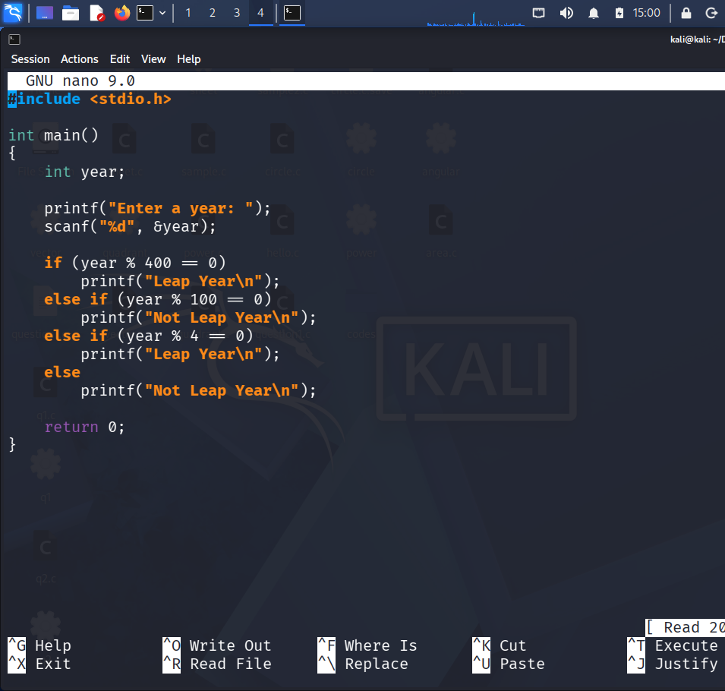
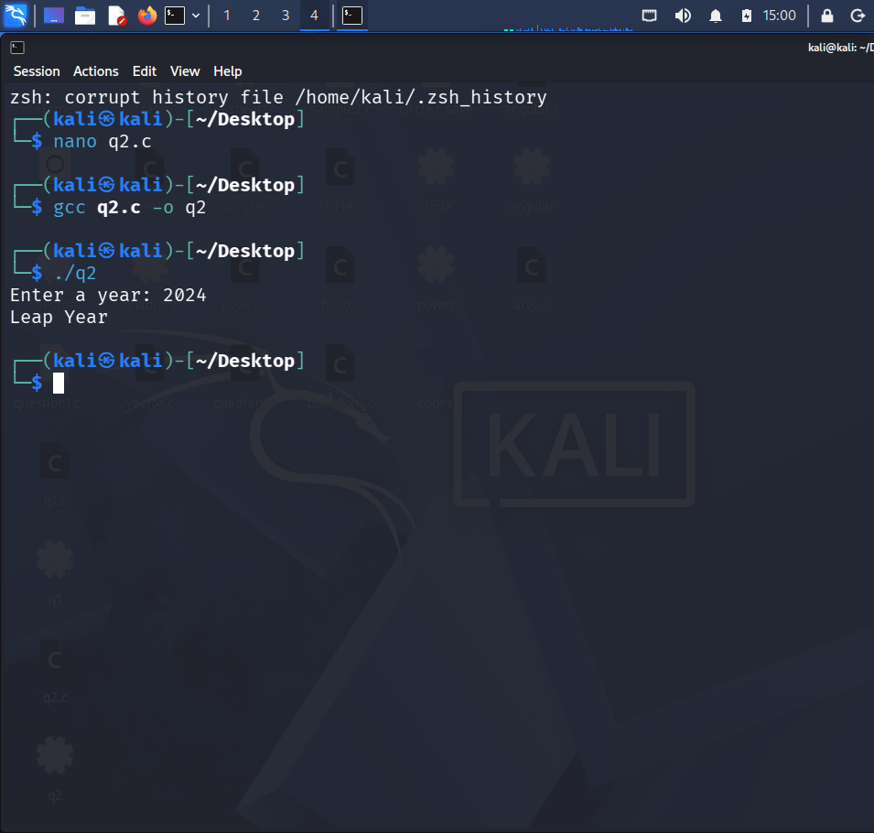
2. Pseudocode
- Start
- Declare year
- Input year
- If year % 400 == 0, print "Leap Year"
- Else if year % 100 == 0, print "Not Leap Year"
- Else if year % 4 == 0, print "Leap Year"
- Else print "Not Leap Year"
- Stop
3. Algorithm
- Start.
- Input the year.
- Check if year is divisible by 400.
- If yes, it is a Leap Year.
- Otherwise check if year is divisible by 100.
- If yes, it is Not a Leap Year.
- Otherwise check if year is divisible by 4.
- If yes, it is a Leap Year.
- Otherwise, it is Not a Leap Year.
- Stop.
4. Test Case Table
Test Case | Input (Year) | Expected Output
1 | 2024 | Leap Year
2 | 2023 | Not Leap Year
3 | 2016 | Leap Year
4 | 2000 | Leap Year
5 | 1900 | Not Leap Year

5. C Program
#include <stdio.h>

int main()
{
int year;

printf("Enter a year: ");
scanf("%d", &year);

if (year % 400 == 0)
printf("Leap Year\n");
else if (year % 100 == 0)
printf("Not Leap Year\n");
else if (year % 4 == 0)
printf("Leap Year\n");
else
printf("Not Leap Year\n");

return 0;
}
6. Sample Output
Enter a year: 2024
Leap Year

